

DEPARTMENT OF

COMPUTER SCIENCE & ENGINEERING

**Experiment-3.1**

**Student Name: Rajiv Paul UID: 20BCS1812**

**Branch: CSE Section/Group: 20BCS_WM-702-A**

**Semester: 5th Date of Performance:31-10-2022**

**Subject Name: DAA lab Subject Code: 20-CSP-312**

**1. Aim/Overview of the practical:**

Code and analyze to do a depth-first search (DFS) on an undirected graph. Implementing an

application of DFS such as

(i) To find the topological sort of a directed acyclic graph.

(ii) To find a path from source to goal in a maze.

**2. Task to be done/which logistics used:**

(i) To find the topological sort of a directed acyclic graph.

(ii) To find a path from source to goal in a maze.

**3. Algorithm/Flowchart (For programming based labs):**

**Topological Sort:**

* Create a stack to store the nodes.
* Initialize visited array of size N to keep the record of visited nodes.
* Run a loop from 0 till N
* if the node is not marked True in visited array
* Call the recursive function for topological sort and perform the following steps.

1. Mark the current node as True in the visited array.
2. Run a loop on all the nodes which has a directed edge to the current node

* if the node is not marked True in the visited array:
* Recursively call the topological sort function on the node
* Push the current node in the stack.
* Print all the elements in the stack.

**Path from source to goal:**

* Mark node as visited.
* Add node to the path vector as it can be a possible path.
* If node == goal node then save this path in result and return.
  + - Then call dfs function on adjacent node if not visited.
* Print result vector

**4. Steps for experiment/practical/Code:**

**Topological Sort:**

#include <bits/stdc++.h> using namespace std;

void dfs(int node, vector<bool> &visited, stack<int> &s, unordered_map<int, list<int>> &adj) {

visited[node] = 1;

for (auto neighbour : adj[node])

{

if (!visited[neighbour])

dfs(neighbour, visited, s, adj);

}

s.push(node);

}

void topologicalSort(vector<vector<int>> &edges, int n, int e) {

unordered_map<int, list<int>> adj; for (int i = 0; i < e; i++)

{

int u = edges[i][0]; int v = edges[i][1]; adj[u].push_back(v);

}

vector<bool> visited(n + 1, false);

stack<int> s;

for (int i = 0; i < n; i++) {

if (!visited[i])

dfs(i, visited, s, adj);

}

cout << "Topological Sort: "; while (!s.empty())

{

cout << s.top() << " "; s.pop();

}

}

int main() {

int n = 6, e = 6;

vector<vector<int>> edges = {{5, 0}, {4, 0}, {4, 1}, {3, 1}, {2, 3}, {5, 2}};

topologicalSort(edges, n, edges.size());

return 0;

}

**Path from source to goal:**

#include <bits/stdc++.h> using namespace std;

void dfs(int node, vector<bool> &visited, vector<int> path, vector<int> &result, unordered_map<int, list<int>> &adj, int src, int goal)

{

visited[node] = 1; path.push_back(node); if (node == goal)

{

result = path;

return;

}

for (auto neighbour : adj[node]) {

if (!visited[neighbour])

dfs(neighbour, visited, path, result, adj, neighbour, goal);

}

}

void pathFinder(vector<vector<int>> &edges, int n, int e, int src, int goal)

{

unordered_map<int, list<int>> adj; for (int i = 0; i < e; i++)

{

int u = edges[i][0]; int v = edges[i][1]; adj[u].push_back(v); adj[v].push_back(u);

}

vector<bool> visited(n + 1, false); vector<int> result;

vector<int> path;

dfs(src, visited, path, result, adj, src, goal);

cout << "Path from " << src << " (source) node to " << goal << " (goal) node: "; for (auto it : result)

{

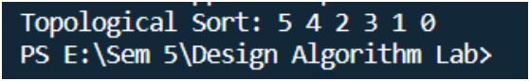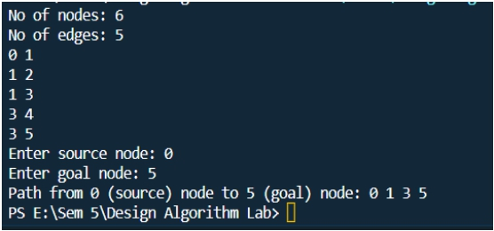

cout << it << " ";

}

}

int main() {

int n, e;

int src, goal;

// Undirected Graph

cout << "No of nodes: "; cin >> n;

cout << "No of edges: "; cin >> e;

vector<vector<int>> edges; for (int i = 0; i < e; i++)

{

int u, v; cin >> u; cin >> v;

edges.push_back({u, v});

}

cout << "Enter source node: "; cin >> src;

cout << "Enter goal node: "; cin >> goal;

pathFinder(edges, n, edges.size(), src, goal); return 0;

}

**5. Observations/Discussions/ Complexity Analysis:**

**Topological Sort:**

**Path from source node to goal:**